Note: Include this page only when adding / amending / deleting a document. If using this document as a record, this Revision History page can be omitted.

REVISION HISTORY

Revision no | Date | Description of Changes | Reason for Revision | Revised by | Approved by
1 | 20 Jun 12 | Add revision history page | Recommendation from Stage 2 audit | CMRojas
2 | 8 Apr 16 | Added disclaimer when printing the document | For document control | RCGanal | MVBergantin
TM-BR-MG- 11 Rev02, 10302015

I. Objective
To make the office supplies available upon request of the employees and to maintain updated and reliable inventory of supplies.
II. Scope
This procedure defines the action and responsibilities of the Administrative Assistant in office supplies acquisition and inventory. This covers activities from the requisition of supplies to updating of inventory.
III. Definition
Requisition Slip | Is a form filled-out by the requesting party only if the items requested are (1) more than three pieces and (2) items come in volume/bulk (i.e. ream, box, etc.).
Inventory Logbook | Is a manual record of the items released and the affixed signature of the requesting party.
Inventory Report | Is a soft copy report which displays the list of supplies available in the office and the number of available stock.

IV. Procedure Details
RESPONSIBLE | ACTIVITY | INTERFACE
Administrative Assistant | 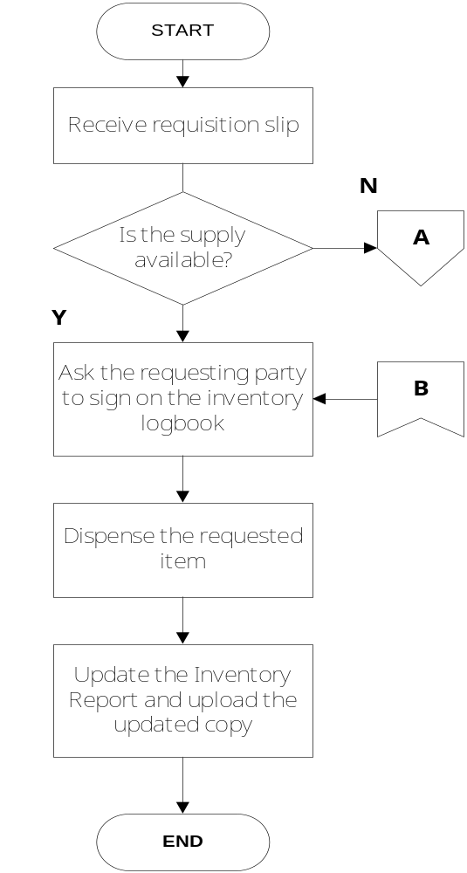 | Requesting Party Requisition Slip  Requesting Party Inventory Logbook  Inventory Logbook  ExeCom Inventory Report Googlesite

RESPONSIBLE | ACTIVITY | INTERFACE
Administrative Assistant | 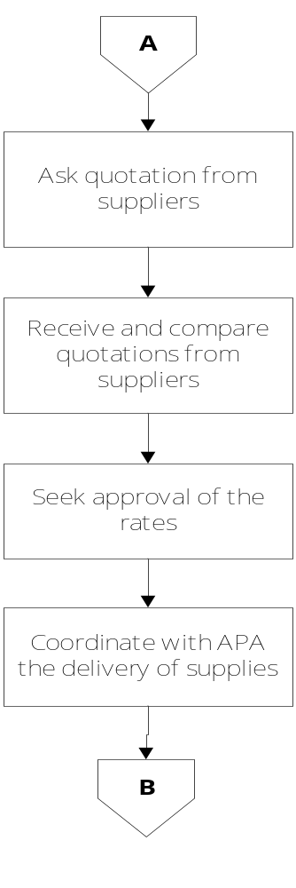 | Suppliers  Quotations  Supplies  ExeCom  Accounts Payable Accountant

V. References
- Requisition Slip
- Guidelines for Requisition and Purchasing

V. Quality Records
- Inventory Logbook
- Inventory Report
- Supplier’s Quotation

